Network Design:
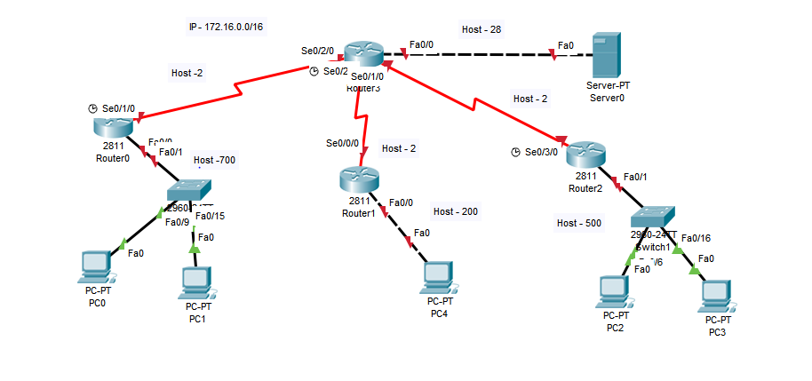

Question:
IP address: 172.16.0.0/16; Default gateway –last valid IP of the range; Routing algorithm (Rip v2)
Router 0: Host 700; Router 1: Host 200; Router 2: Host 500; Router 3: Host 28
Serial: router 0 to router 3 -1st subnet; router 1 to router 3 -2nd subnet; router 2 to router 3 -3rd subnet

